Analysis Stage:
Introduction:
The idea for my game is a 2d platformer, where the title is currently BOSH – for now. The user will play a character who attempts to climb a skyscraper while fighting off enemies. During the climb, they will have to make it through difficult levels while using items that are given to them throughout the game. When it is opened, it will have a start menu that allows the user to start or replay any level they have completed. It will also have an in-game menu that allows you to change settings or leave the game. The game will be controlled by a keyboard. But, as many people have different preferences for what keys they like to press, a feature I would like to add is the ability to rebind the controls to what they would like.
As I enjoy similar games to this idea, like Celeste and Hollow Knight, I want to create another one for myself and others to enjoy, the mechanics of both games are fun and interesting, which is something I would like for mine. The original plan is to give the user items that help them to move across levels and avoid enemies like in both Hollow Knight and Celeste. They also have a good storyline, which isn’t as important to my game, but is certainly I feature I would like to include.
For the project to be a success, I will need to get feedback from people which will help me to analyse the features that will make the game enjoyable. I will give questionnaires and surveys to my stakeholders throughout the project to first; find what characteristics they think is important for a game like this. After that, I will get them to test the program and give them another survey based on their previous answers in order to improve the game, the reason for this is that it aids me in knowing what features to prioritise and focus on to improve the game. I’m using this method instead of just using my ideas as it provides another perspective on the development of the game, allowing me to do things that I otherwise wouldn’t have done, improving the final product.

Research:
Existing solutions:
There are many 2d platformers with similar mechanics to my game, I have researched a few examples which I think are similar to my idea.
Program 1: Celeste
Sources: 1. Celeste | Interface In Game | Video game UI 2. Celeste - Chapter 1 - Strawberries 3. Screenshot from the game 4. Stuck on opening screen 5. Stuck on title screen
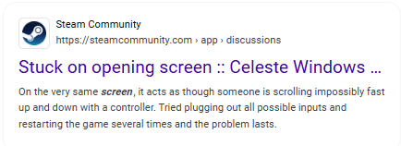
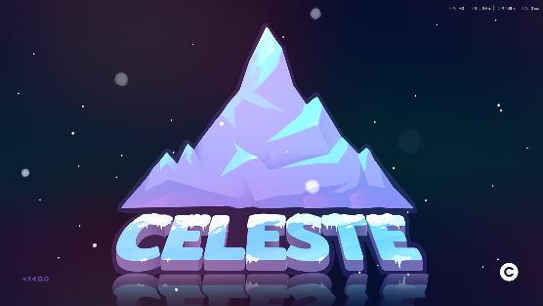
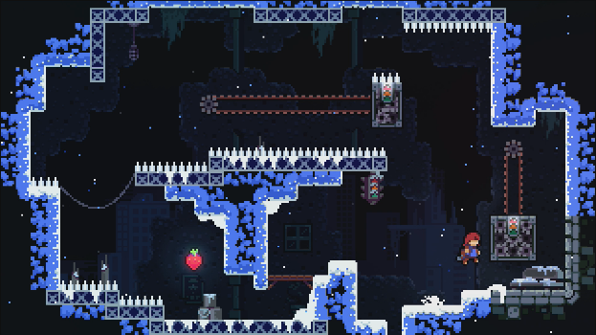
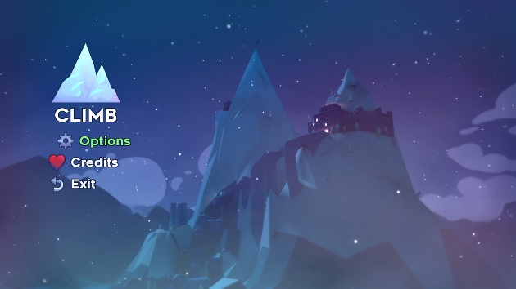

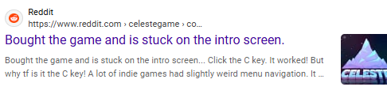

This game starts off a simple menu with a few different options including climb, options and exit, obviously displaying to the user what they can select and do in the game. The menu is set in front of a backdrop of a mountain, which is the main part of the game – where you climb it – again displaying what the game is about.
Despite the menu being simple and understandable, before that, there is a start screen where you have to press ‘C’ to begin, this confuses many people as they think that it’s a copyright symbol, and there are many examples of people being stuck at the very start of the game on places like steam community and reddit, indicating how this is a puzzling way to begin.
After you have started playing, each screen is small, but the platforming is difficult. Even though that may sound annoying or enraging, it doesn’t take long to complete in a successful attempt, so you can retry the level very quickly and get back to the point you were before in a small amount of time.

Things I would like to incorporate into my project | Things I wouldn’t like to use in my project
A large quality of life feature that is overlooked a lot of the time is called ‘Coyote Time’ where the character can still jump for a fraction of a second after leaving a platform, this makes it much easier to time jumps and makes the experience more enjoyable. So, this is something I would like to add into my game. | The controls are very simple – just a dash and a grab added onto the usual movement controls, even though these can be used for complex mechanics. I would like my game to have a specific powerup for each level, which I think would add more variety to the game.
I would like to use the 2d, pixel art style that Celeste uses, I think that in many parts of the game it can look very good, which will appeal to the user and improve the overall experience. I would use this as its easier to create than other art styles due to its simplicity. This also | The game starts off as 3d and then moves into 2d, while this is interesting, I would like my whole game to be 2d as to not confuse the user at first as the switch may be disorienting and give them a false idea of what the program is like.
Small screen size, this allows the user to see the entire level and lets them think about what they should do at the start to try and complete it. This also means that each screen is short and doesn’t take long to complete, which is something I would like to adapt into my project. | Celeste also incorporates screen shake into the levels, I am not fond of this as it can be distracting and makes it harder to see the level, even if it as used to enhance gameplay and make it more immersive.
The menu is clear about every button’s purpose and what will happen if you press them. This is a helpful to include into my project to easily display to the user what’s happening. The game also allows for opening the menu in-game, letting them change settings like key binds and music volume, which is something I would also like to take into my game. | As previously mentioned, the very start requires you to press ‘C’ to begin the game, this confuses many people as they either don’t see it or think it’s a copyright symbol. I would like to make the start button something more intuitive to press, like the spacebar or enter button.
The game allows for the changing of key binds if the user doesn’t like the original ones, this is massively helpful for the user experience and improves the quality of the game. | The game uses ‘X’ and ‘C’ as the starting controls along with ‘ASD’ I think that those buttons are hard to press and can result in stretching/twisting your fingers in weird ways to press them. This can hurt or tire out your hand. I would have the buttons be used in a more ergonomic way that allows the user to more easily press them.

Program 2: Hollow Knight
Sources: 1. HK start menu 2. HK gameplay 3. HK Charms 4. HK Map
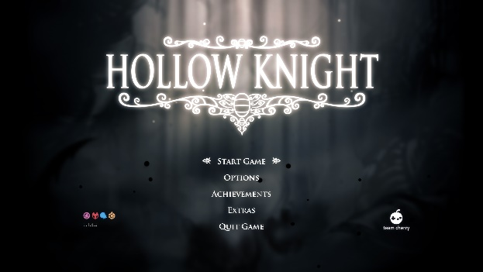
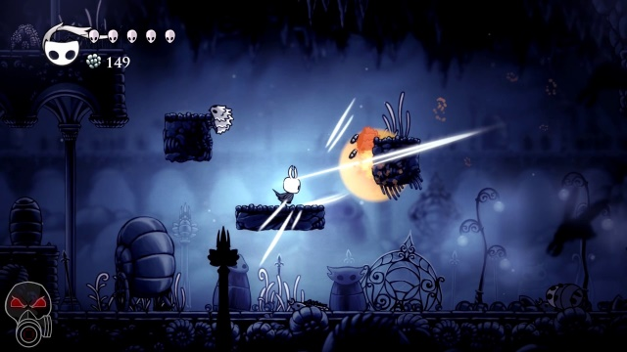

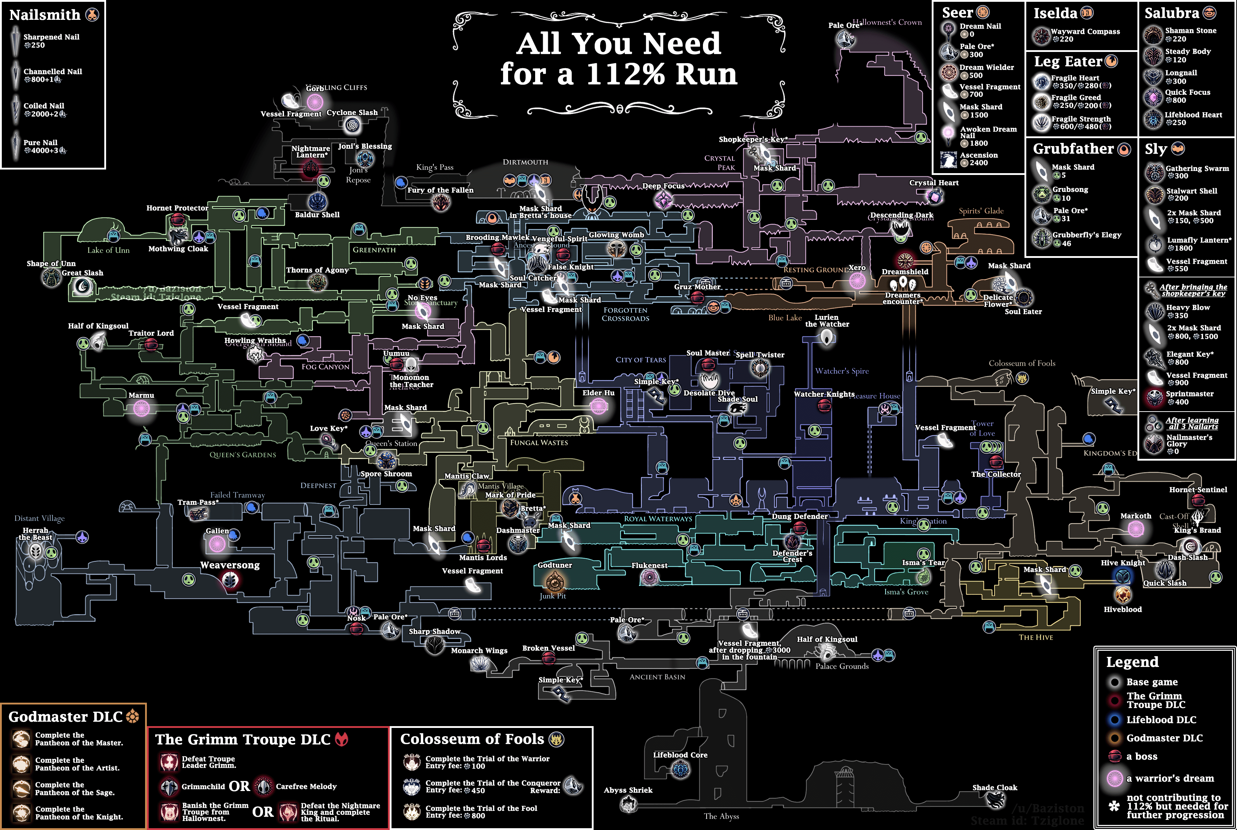
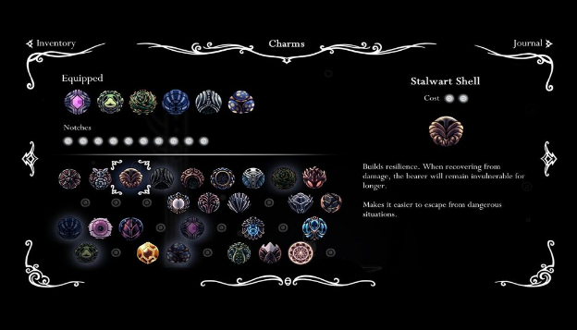
Similar to celeste, the game begins with a simple start menu that clearly displays all the options available to the player, including start, options and exit. The menu has a theme like the game, instantly highlighting the style of the program to the user.
The player character travels around a map where it fights off enemies using its abilities like dodging and certain different attacks, some of these attacks can also be used for platforming, like bouncing off of spikes or enemies.
During the game, you can unlock ‘charms’ which give certain abilities like extra lives or effects that help you in battle – like regeneration or extra lives – or in platforming – like an extra jump or dash. These abilities cost energy and they allow you improve in the game, getting to places you otherwise wouldn’t be able to.
Things I would like to incorporate into my project | Things I wouldn’t like to use in my project
As the menu screen is simple to understand and easy to navigate, this provides a good user experience and is something I would like to include in my game. | The whole world is a large map which many different places on it that you can gradually unlock, this can be very overwhelming to the user at first as they don’t know what anything is or where to go, which can also be frustrating. I would prefer my game to have a linear route which you take rather than spending a lot of time not knowing where to go.
There are many different mechanics that the player can utilise to their advantage, that allow them to jump higher or dash in the air. As this is something that would be important for my game to allow me to add complexity while keeping the fun platforming, I would like to add this to my project. | As there are so many different charms at first, similar to the map, this can be too complicated or confusing for the user, so I would only have a few that impact gameplay as to not be too complex at first.
During the game, there are many enemies which you can fight for small rewards, providing the user with experience or money, I would like to incorporate the potential to fight enemies to make each level more difficult and complex – rather than just jumping around. | The game has certain places where you can save your game, meaning that if you die and haven’t saved in a while, you are forced to restart from a long time ago and lose a lot of progress, I don’t like this and would like the game to save often or whenever the player exits. This would improve the experience for the player, as losing progress can be very frustrating and annoying.
The game has many ‘boss battles’ that take place where the player character has to fight a much stronger enemy than usual, which has its own special ways of attacking that the user has to learn how to avoid. As this may be difficult to add, I would like to adapt it into the end of each level, but only if everything else is to a good standard.

Program 3: Ori and the Blind Forest/ Will of the Wisps
Sources: 1. OatBF menu theme 2. Ori screenshots 3. Ori Map4. Ori Skill Tree
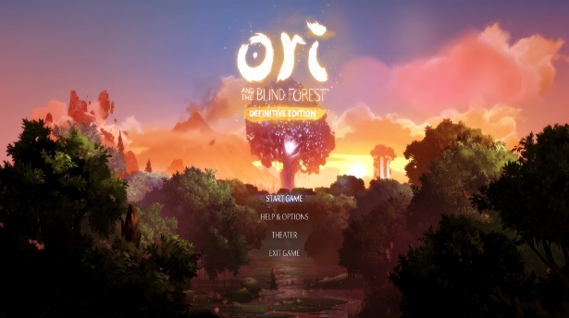
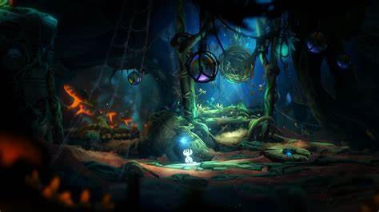

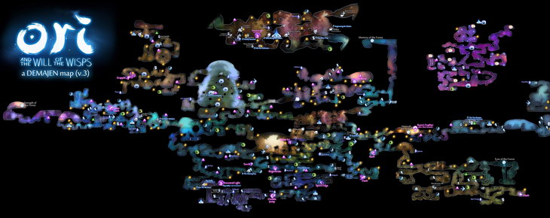
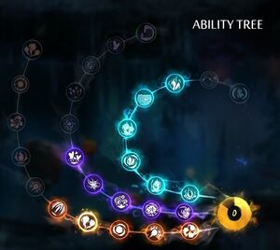
Like Hollow Knight and Celeste, the game starts off with an easy to understand and navigate menu places in front of a beautiful backdrop of where the game will take place, displaying to the user the theme of the program and the centre point of the game – the large tree.
During the game, each level has a massive amount of detail, with foreground elements and a busy background behind the player, fully immersing the character in the forest that they are in.
A large part of the core gameplay is the presence of an ‘ability tree’ which, similar to Hollow Knight, can be unlocked by the player, giving them certain abilities like different attacks or more ways to move.
Things I would like to incorporate into my project | Things I wouldn’t like to use in my project
Like Celeste and Hollow Knight, the menu screen is simple to understand and easy to navigate, this is something I would like to include in my game. | The game is more centred around travelling and fighting enemies, plus the story element, while I would prefer my game to be more platforming focused.
The game adds more mechanics as you progress, like Hollow Knight and also Celeste to an extent, allowing you to get to places you otherwise couldn’t, continuing the story. I would like to incorporate this into my game, adding more ways to move after each level. And potentially allowing the user to retry the level with the new mechanics to unlock things they previously couldn’t. | The ability tree may add too many different things which could be confusing to the user at first, I would not want to include this as I would like the start to be as simple as possible to allow for a wide range of people to enjoy the game.
Large amount of detail - each screen of the game looks good and has a massive amount of detail put into each setting; I would like this to be a part of my game when I create it. | The large map may also be confusing for new players, similar to Hollow Knight, so this is not something I would like as an addition to my game.
 | Parallel to Hollow Knight, Ori also has certain spots where you can save your game, again

Stakeholders:
My program will be aimed at boys aged from 15-18 who like to play videogames, as I, and many other people my age, that I know, like to play these types of games, so my game would appeal to them. Due to each screen being challenging to complete, it isn’t aimed at younger children as they may not like it as much as ones in their late teens. My program also isn’t targeted towards older people, the reason for this is they may not enjoy games as much as the target audience.
I hope to include my stakeholders in the design and development process, by regularly checking in with them, for example - every week, to see if my program fits their requirements and does what they expected of it. This can be to check if it’s on track to meet the user requirements and fix it if it isn’t meeting them.

User Requirements:
My user requirements:
The necessary features of this game:
- A simple start menu where the user can choose to begin or exit the game.
- Basic movement controls that allow the user to move back and forth and jump/double jump, these will be controlled by the arrow/ASD keys and the spacebar.
- Allowing the user to open a menu in the middle of the game, letting them use settings – like changing the volume/key binds - or exit the game. This means that they don’t have to restart the game to change any settings and can just do it quickly and easily from inside the program.
- Spawning at the start of each screen when the character dies and not taking long to respawn – 1 second at most – to allow the player to quickly retry the level without wasting any time.
Features I would like to add:
- A level select screen where the user can choose what level they want to play after it has been unlocked.
- Enemies that the player can interact with, e.g. fighting. If the character is touched/shot by the enemy, they will be reset to the beginning of the screen, providing an extra challenge and complexity over just jumping around.
- Extra movement and powerups unlocked after each level which give the player many more ways to move, e.g. propelled by an explosion/rope swinging, leading to a more fun and interesting experience, where the user has to chain together different abilities to complete each level.
I would add If I had time at the end:
- Similar to Celeste’s ‘golden strawberries’ feature which resets the player to the beginning of the level when they die, providing an extra hard challenge for the player. I would like to add a setting (called ‘hard mode’ for example) that, once all the levels have been completed allows the user to replay the level, but instead of replaying the screen when they die, makes them replay the entire level.
- A multiplayer game mode where you can fight against your friends trying to knock them off using powerups given to you – like in super smash bros or similar games.
- The player being able to earn coins, letting them buy cosmetic items in a shop, like hats or clothes.

User requirements Table:
Green – Essential Yellow – Desirable Red - Optional
Feature | Sub-Feature | Explanation | Justification | Importance
Start menu/ in-game menu | Start button | A button that will take the user to whatever level they were on when they last played, or if they haven’t, it will take them to the first level. | All of the games that I analysed had a clear start button that began the game when clicked. This allows the user to begin the level when they would like instead of instantly being thrown into the action as to not let them miss anything important that happens at the start.
 | Settings button | A button that can be pressed taking the user to the game settings, this lets them change things like key binds and game/music volume. | All of the games I analysed also included this feature at the beginning. It’s helpful as it allows the user to change the volume in-game if it’s too loud/quiet instead of changing the system/headphone sound, potentially messing other things up on the computer making them too loud or quiet.
 | Title screen | Opening screen of the program displaying the name of the game and buttons available to press. | Like the previous sub-features, all three of the programs I researched had this feature. Where the name of the game is clearly visible, indicating to the user what game they are playing.
 | In – game menu | A menu that can be opened using a button that lets to change settings/exit to menu while in game. | If the user’s game sound is too loud or if their key binds are not correct, they will not be able to change them without closing and reopening the game, similar to the justification for the settings button. This can be fixed by having an in-game menu that will fix their problem.
Gameplay | Simple movement mechanics | The ability to move the player around and have them jump/duck plus another extra way of moving to add to the gameplay e.g. a double jump. | For the user to move the character around the level they need to be controlled by the player and given the capability of movement to allow the game to be played.
 | Fun and more complex movement | Extra abilities that are given to the player to allow them to dash or jump higher or propel themselves off in a certain direction that adds more complexity and fun to the simple movement. | If the simple movement mechanics are the only way to move, this could make the whole experience more boring and less fun, providing fewer ways to complete a level. Whereas, if there were more ways to progress with more mechanics, this opens the game up for added creativity and increased ways that people can think of in order to complete a level. | Very desirable
 | Sound effects | Noises that play when an event happens in-game, like a jump or the player dying, these can be created manually or by using royalty free ones online. | This will add to the overall quality of the game, improving the user experience. Although it may be hard to find/create sounds that fit the theme of the game, they will massively improve the game by adding atmosphere and enhancing the immersion for the player.
 | Enemies | Opponents that try to stop you from completing the level that you must either avoid or fight to survive, they would have ways of attacking like swords up close and lasers from afar that you must avoid. | A simple game that just requires jumping around to complete levels would be too simple in my opinion and wouldn’t be as fun to play, simple enemies – not rage inducing as I would like my program to be enjoyable – would add an extra layer of intricacy, hopefully improving the quality of the game as there’s a wider variety of levels.
 | Boss Battles | A boss at the end of each level that the player must fight in order to complete it. They are harder than usual enemies and should have more weapons and health than the average opponent. | Again, this would add more variety to each of the levels and complexity to each stage, finishing would feel like more of an accomplishment, providing the player with more enjoyment after completion than without the difficult fight.
 | Fast respawning | Respawning quickly at the start of each screen when the player dies to allow them to quickly retry the level. | Even though the platforming may be difficult, there are many frequent checkpoints that the player gets reset to when they die that are close to wherever it was, this allows them to retry the screen quickly and make the game enjoyable as it isn’t spent doing jumps that you have beaten before.
Extra Features | Cosmetic Store | A shop where you can buy cosmetic items for your character, these can be different types of hats or clothes that can be bought using in-game currency. | People may not like the original design of the character or just may want to stand out from others; they can use the cosmetic shop to customise their character if they would like. | Difficult to add
 | Multiplayer battles | A game mode where you can fight against your friends using powerups given to you during the fight. Or play through the levels with them in a co-op game mode. | As the original game would be single player, this leaves it less accessible for people to play compared to a multiplayer game. For example, if you were with your friends and wanted to play a game with them, this program wouldn’t be an option at first. But it would be open to a wider range of people if multiplayer was a feature of the game. | Very difficult to add
 | Hard mode | Where the player starts from the beginning of the level when they die compared to just the start of the screen they were on, adding an extra challenge to the game. | This would be a much harder challenge compared to the normal game that not everyone can complete. This will provide players that have beaten the game with an even more difficult task. As its much harder it may not be as enjoyable as the main game, so its optional/only playable after the game has been completed. | Not a necessary feature

Limitations:
I have labelled some of my features as optional, which means that its something that I or my stakeholders would like to be present in the game, but they would be too difficult/ time consuming to add, or something I would integrate at the very end, because of this, I have decided their importance is red and given a reason as to why I think that is.
Cosmetic store:
The results of the survey show that this would be a part of the game that many people will use as 16/18 voted yes and 1/18 voted no. Because of this, it’s a feature I would like to add to my program, but due to the amount of added time that coding and asset creation will take, it’s only something that I will add at the very end, if my game is up to a good standard of gameplay and there’s enough levels (3-4).
Multiplayer Battles:
Again, the survey results indicate that this would be a very welcome feature as many people enjoy playing games with their friends. But, due to the massive difficulty of making multiplayer just work, with the added trouble of making it work well, this is definitely something I will not be doing unless I have a lot of time to spare.
Hard Mode:
This is a feature of other games that I enjoy and find interesting, even if it can be annoying and incredibly hard at times. Therefore, this is a feature that I would like to integrate into my game. As this is certainly not a feature that’s necessary or improves the game by a large margin, it is not one that I would prioritize over the other more important ones like interesting and fun platforming/mechanics.

Stakeholder Survey:
To find out what features of my program that would be most liked by my stakeholders, I gave a few of my friends who liked videogames (aged 16-17) a short survey asking questions that would influence the choices I make when programming. These questions are as follows:
- Do you like to play video games?
This is to indicate the amount of people taking the survey who have an idea about what makes a game fun to them and how useful their input will be on the survey.
- What are your favourite games to play?
This is to find out what games are popular, and which ones have been played the most, this shows what game aspects the stakeholders have experience with and are more qualified to comment on.
- Please rank these based on how important they are in a 2d platformer
This is to find out what games are popular, and which ones have been played before, allowing the stakeholder to use their experience in previous games to influence what I include in mine, and what I should prioritise to provide the best user experience possible.
- On top of WASD/arrow keys, what other keywords would you use for other movement buttons?
The point of this simple question was to find the most popular key binds that people use while playing games, so that the default ones for my game would appeal to the widest range of people, allowing them to start immediately rather than wasting time trying to figure out the best keys for them.
- What is more important – mechanic variety/level variety
This is another simple question that is purely just to figure out which of mechanic or level variety that people prefer more, letting me know what i should prioritise in my game.
- Would you use a cosmetic store?
Again, this a simple question to find out whether this would be a welcome addition to the game or not.
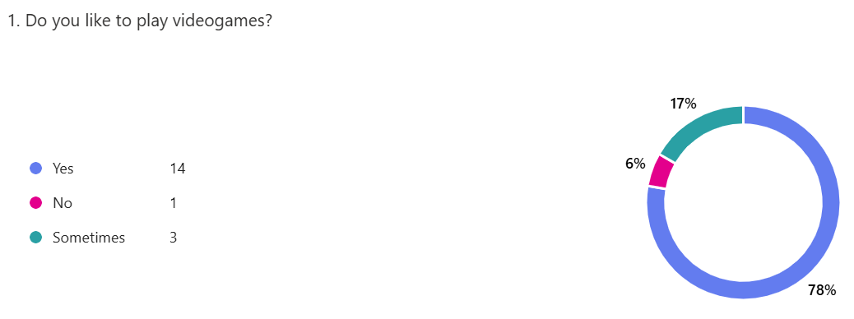
As most of the answers are yes, this shows that the question is doing its purpose by showing that the stakeholders have some sense of knowledge on games and therefore are helpful in providing information for the survey.
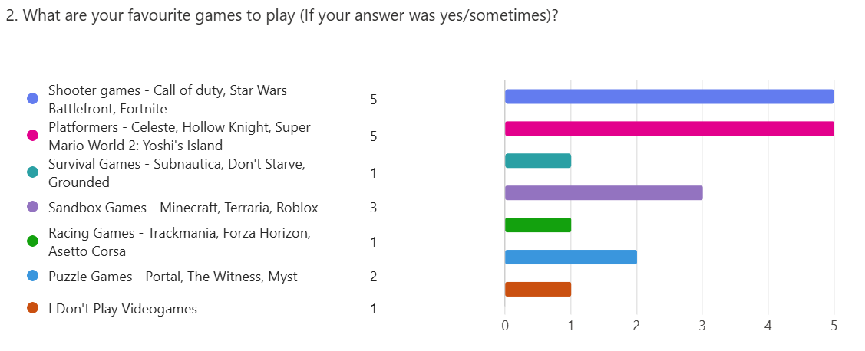
These answers indicate the amount of people that have played each genre of game, highlighting which ones they know the most.
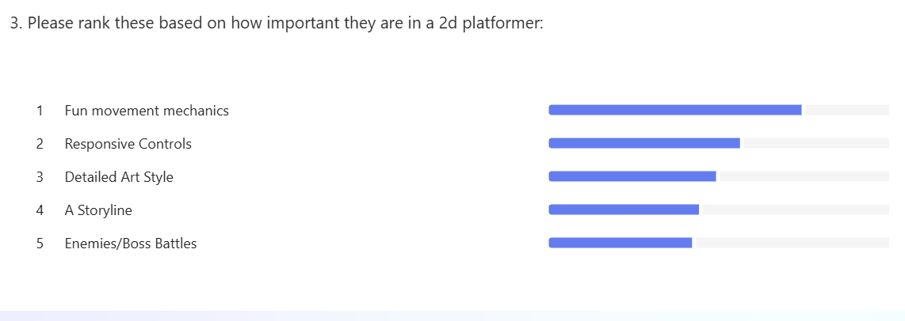
The responses to this question show to me the order of features that I should focus on and how I should prioritize them based on which ones are decided to be most important.
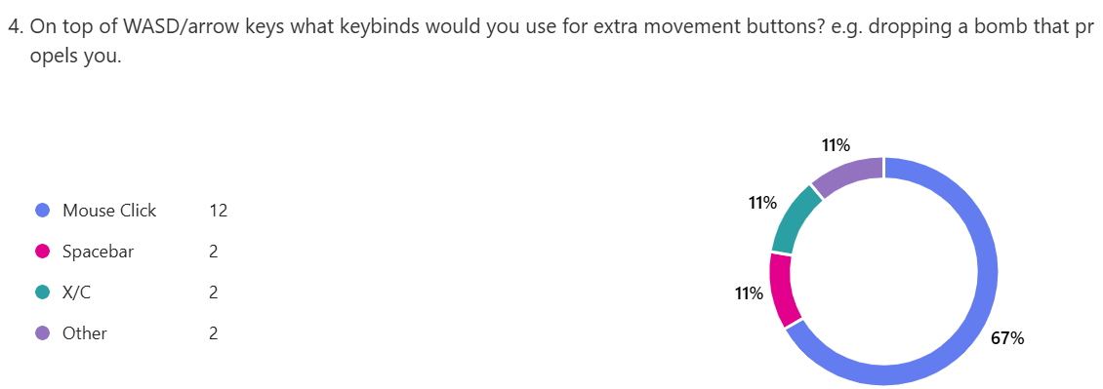
This question just tells me what the most popular controls are and which ones I should default to each action in game.
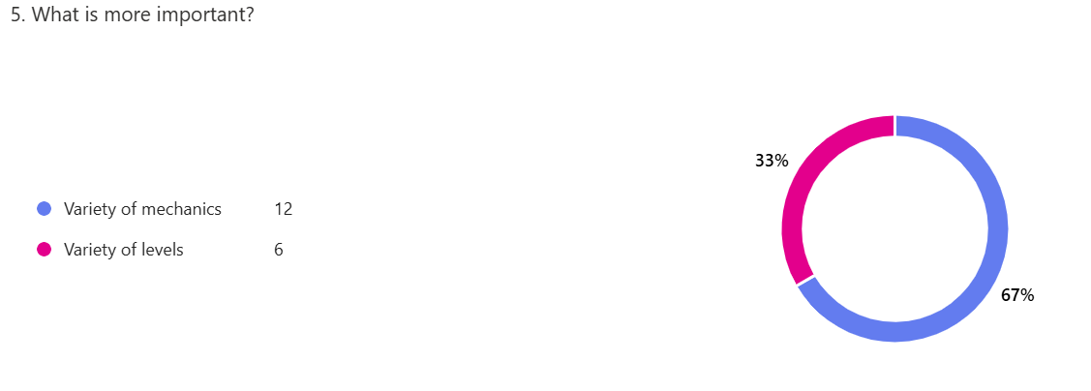

Again, this question indicates which features I should prioritize through which option the stakeholders believe is more important.

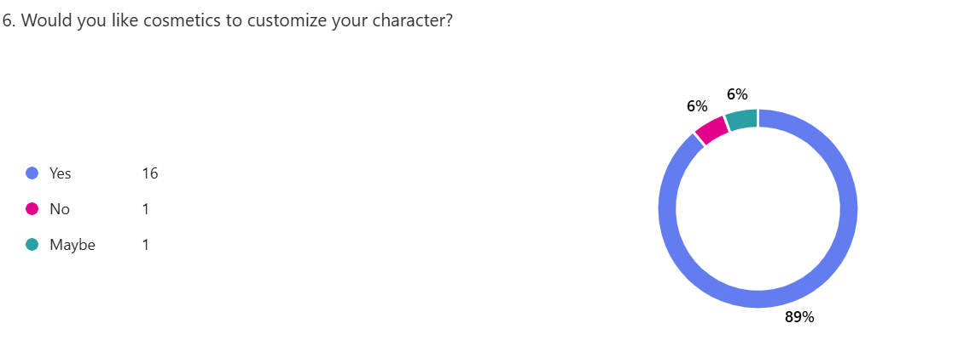

The answers to this question fully indicate that the stakeholders would like the option of character customization. Thus, this is definitely something I should add if I have time, due to this being a low priority feature.

Hardware and Software Requirements:
To design this game, I will be using unity and will be coding in C#, the operating system I will use is Windows.
Hardware:
- As I will be making the game in unity, the hardware should just be able to run that, because it’s a 2d game the requirements shouldn’t be much more
- A keyboard and mouse should be used to provide inputs for the game
- As it would have sound effects, speakers/headphones should be used
Software:
- The game will be made in unity, so the only Software Requirements would be an operating system that can run it.
- Need to download the game to play it
Features that Make this Problem Solvable by Computational Methods:
The program will use unity to create the movement of the player, requiring a large number of calculations to simulate the player in motion, especially if it is moving quickly or at an angle. A computer is able to perform these calculations very quickly, allowing the game to run smoothly, improving the user experience.
Aspects of the game will have tasks that run concurrently, like the playing of sound effects and movement of the player and enemies at the same time. On top of this, there will be collision and player detection to check if the player dies – to be able to reset them to the beginning - or is near an enemy – to allow the enemy to target the player character. Both these tasks will be constantly running to always be checking for the player.

This problem is amenable by computational methods for the following reasons:
Decomposition - The main aspects of my game can be broken down into multiple separate problems
- The player movement
- Enemies and attacking the player, including the boss battles
- Level creation
Each of these problems would be difficult to complete, but accomplishing all of them to a high standard would put my game in a good position to be finished.
Abstraction - Many smaller problems within the program would be abstracted, making them far more solvable.
This means, when I am making something like the movement, I will ignore other factors that make it more complicated and focus on them later, e.g. more ways to move, as those aren’t as necessary. Another example of this would be just focusing on the gameplay aspect of each problem, rather than how it looks, and centre the attention onto that once I am happy with how it is to play.

